|  |
| --- |
| 01.05.2018 |

|  |
| --- |
| Client Meeting 1 |

## Attendees

Micro:bit Representatives: Jonny Austin, Joe Finney, David Whale, Kavita Kapoor

Project Team Members: Katarina Boskovic, Luke Bussel, Jacopo Carrani, Aphodite Christodoulou, Abhinaya Mathivanan, Shaun Price

Supervisor: Ed Stott

## Location

British Computing Society (Micro:bit offices)

## Project Introduction

* Project Brief: To build a mega:bit, i.e. a bigger version of the micro:bit (replica), in which students can plug in their microbit and demonstrate their work to the whole class.
* Micro:bit features: The micro:bit is a small microprocessor with on board peripherals. It uses a nRF51 processor and has a 5x5 LED matrix, 2 buttons, GPIO pins, Bluetooth radio, RF radio, magnetometer, accelerometer.

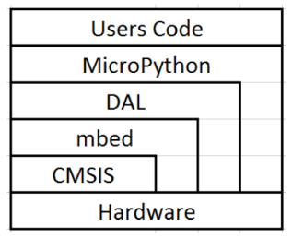

* Explanation of software structure: Several levels exist to translate the user code down to the hardware level. Each ‘sits’ on the top of the next and is procedurally stepped down to the hardware control. However, in some case, mbed, DAL, and microPython can access the hardware directly.
* Existing prototype: The LED matrix is directly soldered to the micro:bit matrix. The micro:bit uses its own sensors and simply drives the extended peripherals on the sample mega:bit. The problem is that with soldering you cannot simply plug a micro:bit onto it and other functions such as light sensing, compass and accelerometer are affected.

## Discussed Solutions

* Accessibility Pin: One of the GPIO pins is a ‘reserved accessibility pin’, which could be used to run the larger LED matrix.
* I2C: The larger LED matrix could be controlled via the I2C bus. There were concerns with the timing requirements of the I2C communication which could possibly interfere with Bluetooth and RF radios.
* USB: Possibly provide two way communication to control the mega:bit or ‘clone’ the code onto the mega:bit.

## Additional Points

* Manufacturing: At least one mega:bit per school, meaning at least 5000 units required. Consider price costs for mass production
* 4 Sensors: Accelerometer and magnetometer of the micro:bit must be aligned with the mega:bit. Light and temperature sensors must provide the same data when the micro:bit is plugged in.
* Additional features: LED matrix at the back of the Mega:bit, haptic feedback for visually impaired who cannot see the LED matrix

## Client Criteria & Conclusion

* Certification
* Manufacturing/ Scalability
* Firmware Complexity
* Safety and Usability
* Reliability
* Cost
* Transparency
* Existing accessibility API
* Sensor functionalities

It was agreed that we would have weekly check-in sessions with the client so that the progress is monitored.

All the communications with the client and the micro:bit community are done on their slack channel which all team members should join.